“Apache Spark™ is a unified analytics engine for large-scale data processing." It is an open-source, distributed computing engine, and it provides a productive environment for data analysis owing to its lightning speed and support for various libraries.

AmazonEMR-ServiceRole-20240706T212813

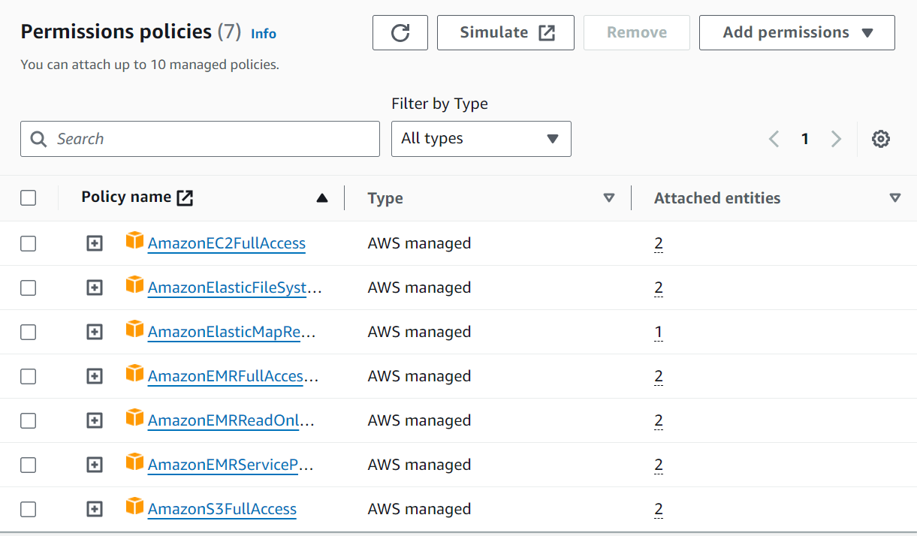

EMR CLUSER

ETL_ASSIGNMENT

ETL STUDIO

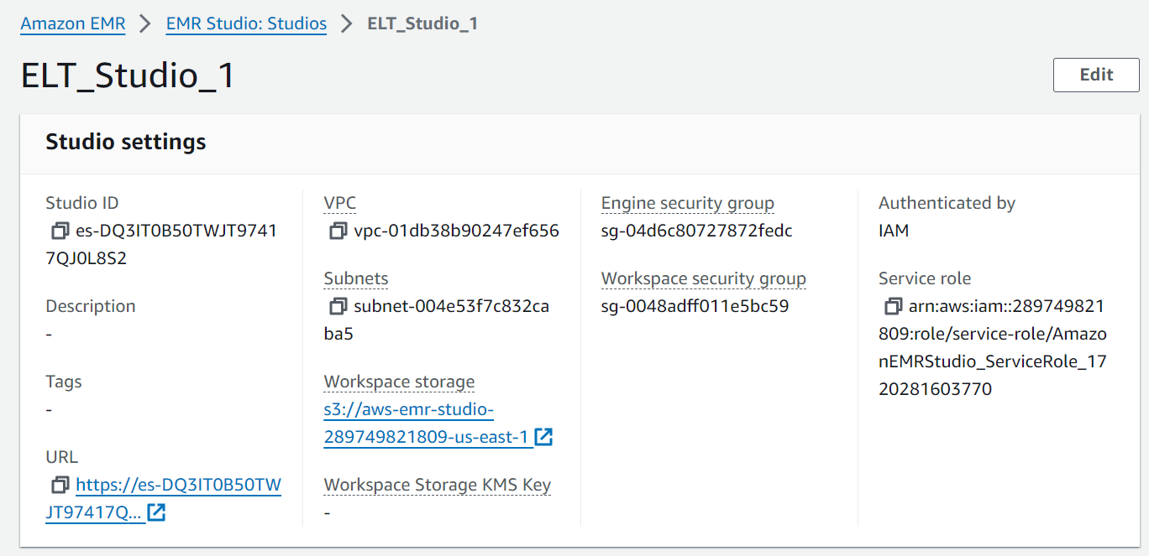

AmazonEMRStudio_ServiceRole_1720281603770

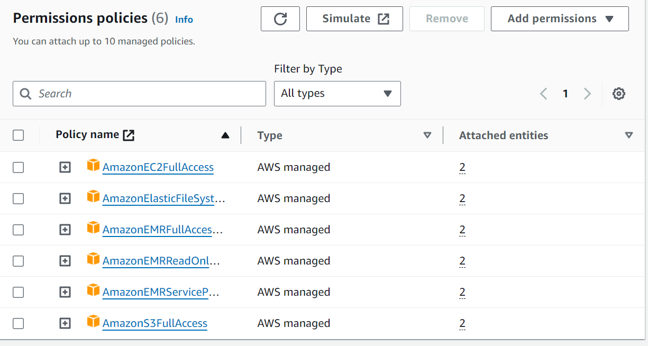

Jupiter NoteBook

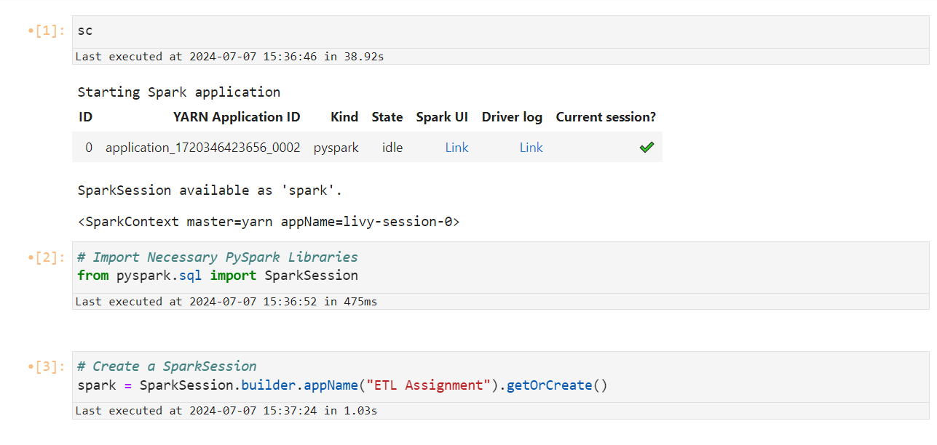

# Start the Spark Application

sc

# Import Necessary PySpark Libraries

from pyspark.sql import SparkSession# Create a SparkSession

# Create a SparkSession

spark = SparkSession.builder.appName("ETL Assignment").getOrCreate()

# Read Data from Hadoop Cluster and Store it in a DataFrame

df = spark.read.format("csv").option("header", "false").option("inferSchema", "true").load("/user/hadoop/atm/part-m-00000")# Show DataFrame schema

# Count the Number of Rows Imported

df.count()

# Show First Few Rows of DataFrame

df.show()

# Show DataFrame Schema

df.printSchema()

# Import Necessary Libraries

from pyspark.sql.types import StructType, StructField, IntegerType, StringType, BooleanType, DoubleType, LongType

# Create the Columns for the Dataframe

df_schema = StructType([StructField('year', IntegerType(), nullable = True),

StructField('month', StringType(), True),

StructField('day', IntegerType(), True),

StructField('weekday', StringType(), True),

StructField('hour', IntegerType(), True),

StructField('atm_status', StringType(), True),

StructField('atm_id', StringType(), True),

StructField('atm_manufacturer', StringType(), True),

StructField('atm_location', StringType(), True),

StructField('atm_streetname', StringType(), True),

StructField('atm_street_number', IntegerType(), True),

StructField('atm_zipcode', IntegerType(), True),

StructField('atm_lat', DoubleType(), True),

StructField('atm_lon', DoubleType(), True),

StructField('currency', StringType(), True),

StructField('card_type', StringType(), True),

StructField('transaction_amount', IntegerType(), True),

StructField('service', StringType(), True),

StructField('message_code', StringType(), True),

StructField('message_text', StringType(), True),

StructField('weather_lat', DoubleType(), True),

StructField('weather_lon', DoubleType(), True),

StructField('weather_city_id', IntegerType(), True),

StructField('weather_city_name', StringType(), True),

StructField('temp', DoubleType(), True),

StructField('pressure', IntegerType(), True),

StructField('humidity', IntegerType(), True),

StructField('wind_speed', IntegerType(), True),

StructField('wind_deg', IntegerType(), True),

StructField('rain_3h', DoubleType(), True),

StructField('clouds_all', IntegerType(), True),

StructField('weather_id', IntegerType(), True),

StructField('weather_main', StringType(), True),

StructField('weather_description', StringType(), True)])

# Load the Hadoop Data with Defined Schema

df = spark.read.format("csv").option("header", "false").schema(df_schema).load("/user/hadoop/atm/part-m-00000")

**Data Processing with PySpark ● Check count after importing data into a dataframe Count of Records – 2468572**

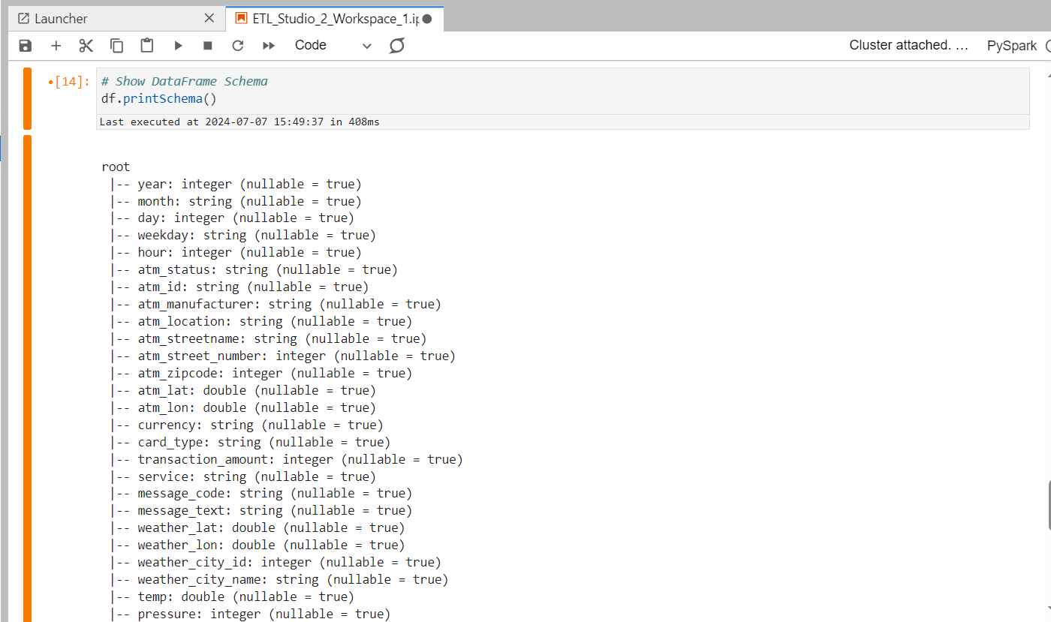

# Drop Duplicates

df_unique = df.dropDuplicates()

# Number of Records Post Removal of Duplicates

df_unique.count()

rds_sqoop_hadoop_spark_df_s3

# Specify the S3 bucket path where you want to save the files

s3_bucket_path = "s3a://rds-sqoop-hadoop-spark-df-s3/test/"

# Write DataFrame to S3 bucket as CSV files

df.write.csv(s3_bucket_path, mode='overwrite', header=True)